San Jose State University

EE250 (Section 2) Fall 2019 Prof. Kamali

Problem Set #3

- Problem 4.18
- Problem 4.26
- [Midterm, Fall 2008] The pdf of a random variableis shown in the following figure.

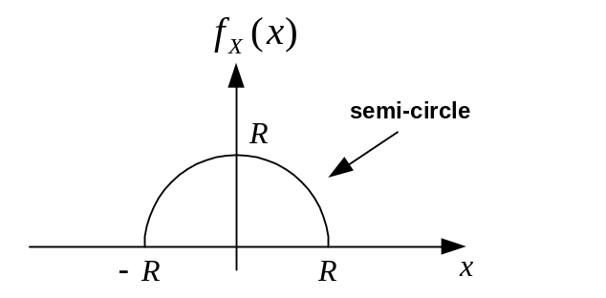

- Find .
- Find 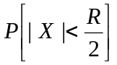.
Note: You must simplify your final answers into a number.

Hint: The change of variable 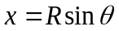may be useful.

- [Final exam, Fall 2011] Supposeis an exponential random variable with unit mean. Find 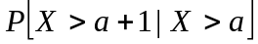 where .

- [Midterm, Spring 2015] Suppose is a continuous random variable with the following pdf.

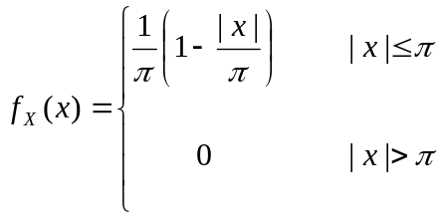

Find 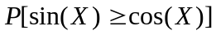 .

- [Midterm, Spring 2015] The pdf of a continuous random variable 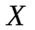 is given as follows.

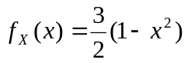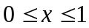

Find 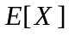 and 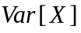.

- [Midterm, Spring 2009] The pdf of a continuous random variable is given as follows.

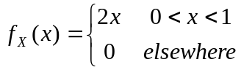

Find such that 

